{Part 2}

Static routing

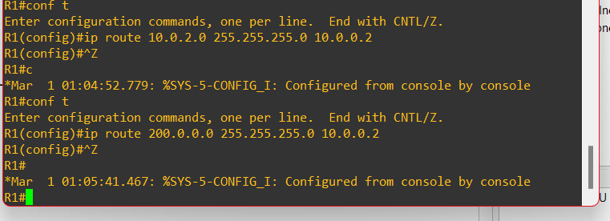

Image 2.1 : configuring static routing to R1

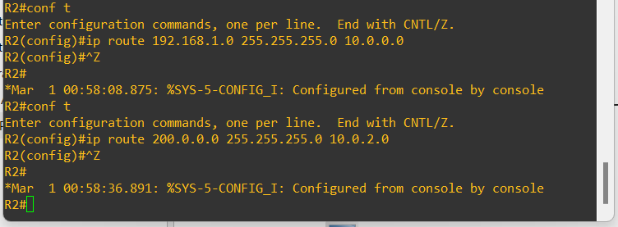

Image 2.2 : configuring static routing to R2

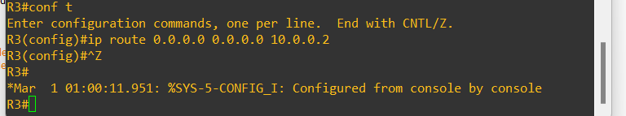

Image 2.3 : configuring static routing to R3

When we try pinging from PC1 to R2 , the connection wont work and returns as host not reachable as the static routing is connected in such a way that R1 pings from PC1 only reaches R2. But, the reply R2 to PC1 will not be received at PC1 and returning the error

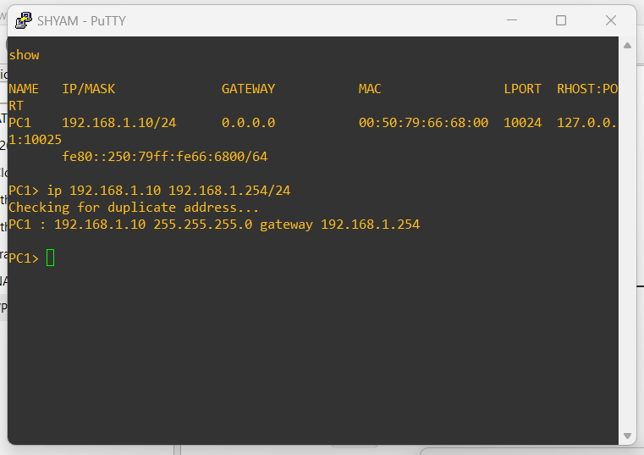

Image 2.4 : pinging the ip from PC1

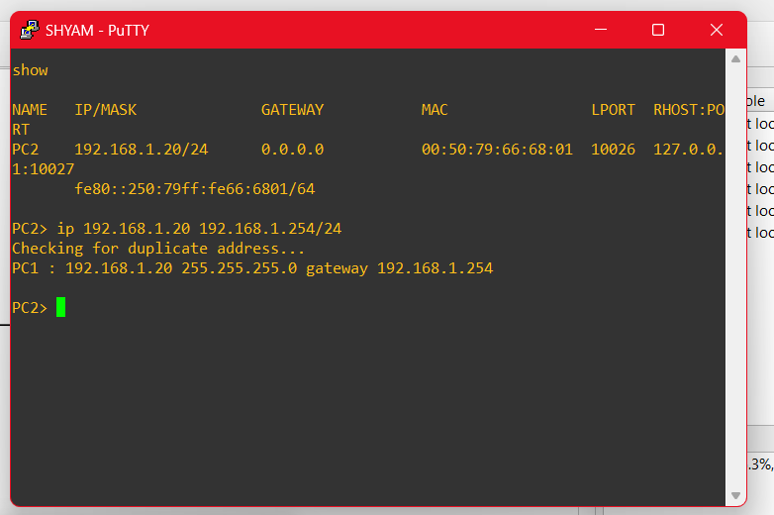

Image 2.5 : pinging IP from PC2

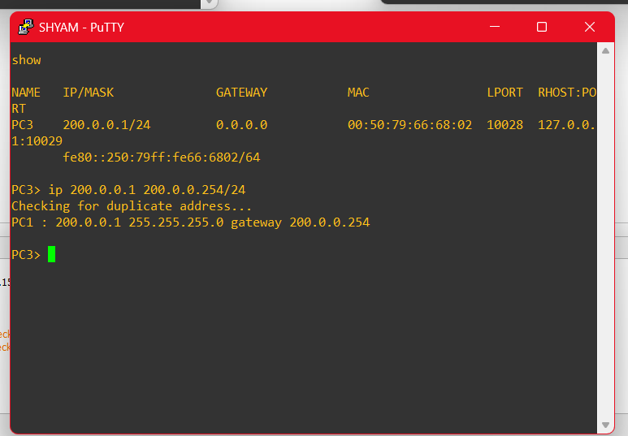

Image 2.6 : pinging ip from PC3